Software Design Document (SDD)
Module: I2C Driver
Version | 1.0
Authors | David Mijares, Ximena Cedillo, Xavier Clemente
Files | I2C.h / I2C.c
Target MCU | STM32F411RE (Cortex-M4) — I2C1 peripheral
Course | Microcontrollers and Embedded Systems — CETYS Universidad

1. Introduction

1.1. Purpose
This document describes the software design and architecture of the I2C driver module developed for the STM32F411RE microcontroller, as part of the Microcontrollers and Embedded Systems lab at CETYS Universidad. The design is based on the code in I2C.h and I2C.c and provides details on data structures, register-level algorithms, and control flow to guide implementation, review, and testing.
This SDD serves as a reference for maintenance and future improvements of the I2C1 communication firmware used in the Lab 5 MPU6050 sensor integration.

1.2. Scope
The I2C driver is a low-level software component that abstracts the STM32F411RE I2C1 peripheral registers and exposes a clean C API. The system performs the following operations:
- Computes the Clock Control Register (CCR) value for a desired SCL frequency using integer arithmetic.
- Computes the TRISE (Rise Time) register value based on I2C mode and peripheral clock frequency.
- Initializes I2C1: enables APB1 clock, resets CR1/CR2, writes CCR and TRISE, disables all interrupts, and sets the PE enable bit.
- Writes multiple bytes to a specific internal register of an I2C device (START + ADDR + REG + DATA + STOP).
- Writes multiple bytes directly to an I2C device without register addressing (START + ADDR + DATA + STOP).
- Reads multiple bytes from a specific register (write phase + repeated START + read phase with ACK/NACK).
- Reads multiple bytes directly from an I2C device without register addressing.
- All operations are blocking (polling); no interrupts or DMA are used.

1.3. Definitions and Acronyms
Term | Definition
I2C | Inter-Integrated Circuit — two-wire serial protocol (SCL + SDA)
I2C1 | I2C peripheral instance 1 on STM32F411RE; located on APB1 bus
SCL | Serial Clock Line — clock signal driven by the master
SDA | Serial Data Line — bidirectional data signal
CCR | Clock Control Register — integer divisor for SCL period generation
TRISE | Rise Time Register — maximum number of APB1 clock cycles for SDA/SCL rise
CR1 | Control Register 1 — PE (bit 0), ACK (bit 10), START (bit 8), STOP (bit 9)
CR2 | Control Register 2 — ITEVTEN, ITBUFEN, ITERREN interrupt enable bits
SR1 | Status Register 1 — SB, ADDR, TXE, RXNE, BTF flags
SR2 | Status Register 2 — BUSY, MSL, TRA flags; read clears ADDR when combined with SR1
DR | Data Register — byte written here for TX; read here for RX
SB | Start Bit flag in SR1 — set when START condition has been generated
ADDR | Address sent flag in SR1 — set after address and ACK received
TXE | Transmit Data Register Empty flag — set when DR is ready for next byte
RXNE | Receive Data Register Not Empty flag — set when DR contains received data
BTF | Byte Transfer Finished flag — set when a complete byte has been transferred
ACK | Acknowledge — bit 10 in CR1; enables automatic acknowledgment of received bytes
NACK | Not Acknowledge — clearing ACK bit before last byte signals end of read sequence
PE | Peripheral Enable bit (CR1 bit 0) — enables the I2C peripheral
APB1 | Advanced Peripheral Bus 1 — I2C1 clock source; max 42 MHz on STM32F411RE
rSTART | Repeated START — a second START condition without a STOP; used to switch from write to read
SLC_FREQ | Macro in I2C.h — default SCL frequency = 100 000 Hz (Standard Mode)
FR-x | Functional Requirement x as defined in this document

1.4. Requirements
All functional requirements implemented in I2C.h / I2C.c are listed below.
Req. ID | Type | Description
FR-1 | Functional | i2c_calc_ccr() shall compute the CCR register value as SystemCoreClock / (2 * scl_freq_hz).
FR-2 | Functional | i2c_trise() shall compute the TRISE register value using the standard rise times: 1000 ns (<=100 kHz), 300 ns (<=400 kHz), 120 ns (>400 kHz).
FR-3 | Functional | i2c_init() shall enable the I2C1 peripheral clock, reset CR1 and CR2, write CCR and TRISE based on SLC_FREQ, disable all interrupts, and enable the peripheral (PE bit).
FR-4 | Functional | i2c_writeRegDevice() shall perform START, address+write, ADDR clear, register address write, multi-byte data write, BTF wait, and STOP.
FR-5 | Functional | i2c_writeDevice() shall perform START, address+write, ADDR clear, multi-byte data write, and STOP without register addressing.
FR-6 | Functional | i2c_readRegDevice() shall perform a write phase (START+ADDR+REG) followed by a repeated START, address+read, ACK enable, multi-byte read with NACK+STOP on the last byte.
FR-7 | Functional | i2c_readDevice() shall perform a dummy write phase (START+ADDR) followed by repeated START, address+read, multi-byte read with NACK+STOP on the last byte.

2. System Architecture

2.1. High-Level Design
The I2C driver follows a layered firmware architecture separating application logic from hardware access:
- Application Layer (main.c): Calls MPU6050 sensor functions. Never accesses I2C registers directly.
- Sensor Driver Layer (MPU6050.c / MPU6050.h): Calls i2c_init(), i2c_writeRegDevice(), and i2c_readRegDevice() to communicate with the sensor. Also configures GPIO pins for SCL and SDA.
- I2C Driver Layer (I2C.c / I2C.h): The only layer that accesses I2C1 hardware registers (CR1, CR2, CCR, TRISE, SR1, SR2, DR) and RCC APB1ENR. Provides a validated polling API.
- GPIO Driver Layer (GPIO.c / GPIO.h): Configures PB8 (SCL) and PB9 (SDA) to AF4, open-drain, with pull-up resistors. Called by the sensor driver during initialization.
- Hardware Layer: STM32F411RE I2C1 peripheral registers and RCC, accessed through CMSIS I2C_TypeDef and RCC_TypeDef structures from stm32f4xx.h.

2.2. Class Diagram
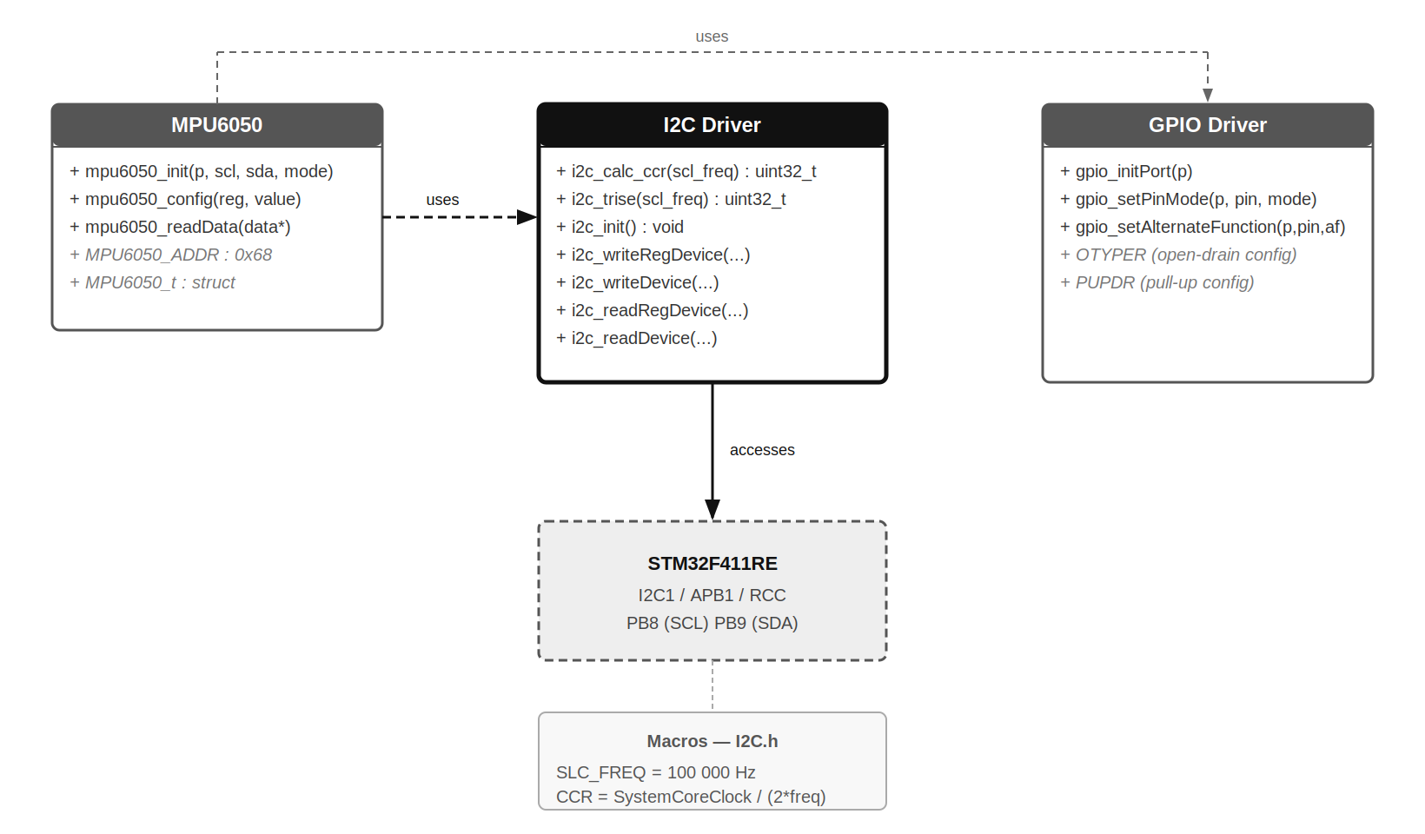
Fig. 1 — Class Diagram: I2C Driver Module
Fig. 1 shows the three software modules and their relationships. The MPU6050 sensor driver depends on both the I2C driver (for all bus transactions) and the GPIO driver (for pin alternate function configuration during initialization). The I2C driver directly accesses the STM32F411RE I2C1 hardware. The SLC_FREQ macro is defined in I2C.h and consumed by i2c_init().

2.3. Module Interfaces
- Public API (I2C.h): i2c_calc_ccr(), i2c_trise(), i2c_init(), i2c_writeRegDevice(), i2c_writeDevice(), i2c_readRegDevice(), i2c_readDevice().
- Key Macro: SLC_FREQ = 100000 — default SCL clock in Hz for Standard Mode operation.
- Dependencies: stm32f4xx.h (CMSIS I2C_TypeDef, RCC_TypeDef), stdint.h. No HAL or LL library.

3. Detailed Design

3.1. Module Description
The I2C driver (I2C.c / I2C.h) provides full I2C1 master-mode communication for the STM32F411RE using direct register access and polling. It supports four transfer patterns: write-to-register, write-direct, read-from-register, and read-direct. All operations are blocking; the CPU polls status flags until the hardware signals completion.

3.2. CCR and TRISE Calculation — FR-1, FR-2
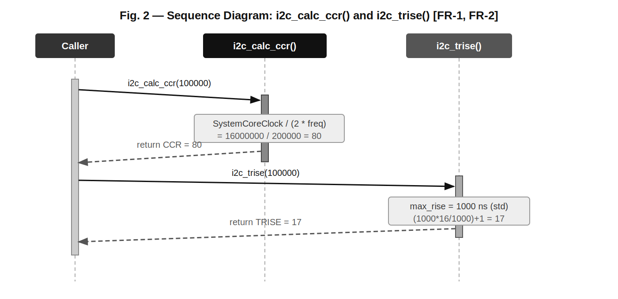
Fig. 2 — Sequence Diagram: i2c_calc_ccr() and i2c_trise() [FR-1, FR-2]
Fig. 2 shows both helper functions called with SLC_FREQ = 100 000 Hz on a 16 MHz clock. i2c_calc_ccr() returns 80 (16 000 000 / 200 000) and i2c_trise() returns 17 using the standard-mode 1000 ns rise time formula: (1000 * 16 / 1000) + 1 = 17. These values are written directly to I2C1->CCR and I2C1->TRISE by i2c_init().

3.3. Initialization — FR-3
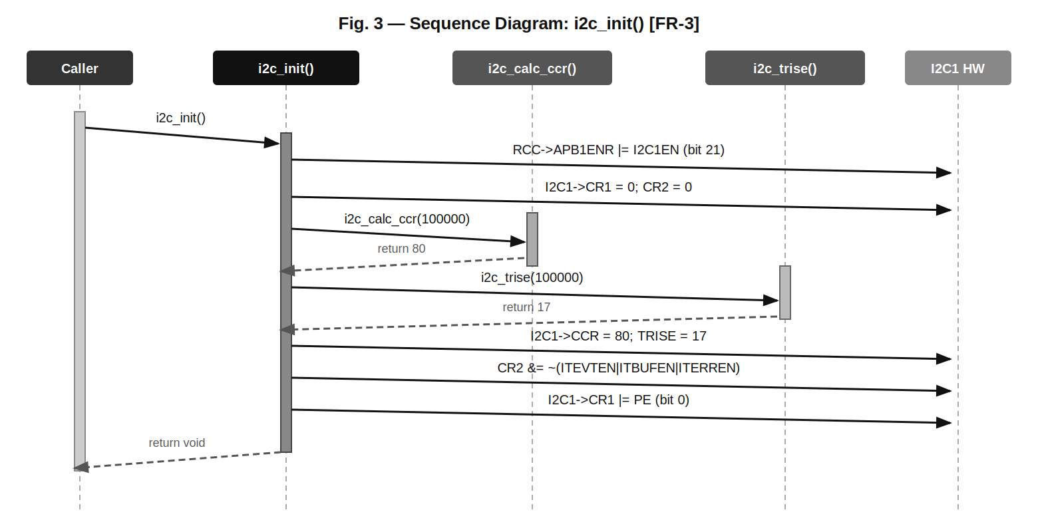
Fig. 3 — Sequence Diagram: i2c_init() [FR-3]
Fig. 3 shows the complete initialization sequence: the APB1 clock is enabled for I2C1 via RCC->APB1ENR bit 21, the control registers are reset to 0, the helper functions are called to obtain CCR and TRISE, the values are written to the corresponding registers, all interrupt sources are disabled, and finally the PE bit is set to enable the peripheral.

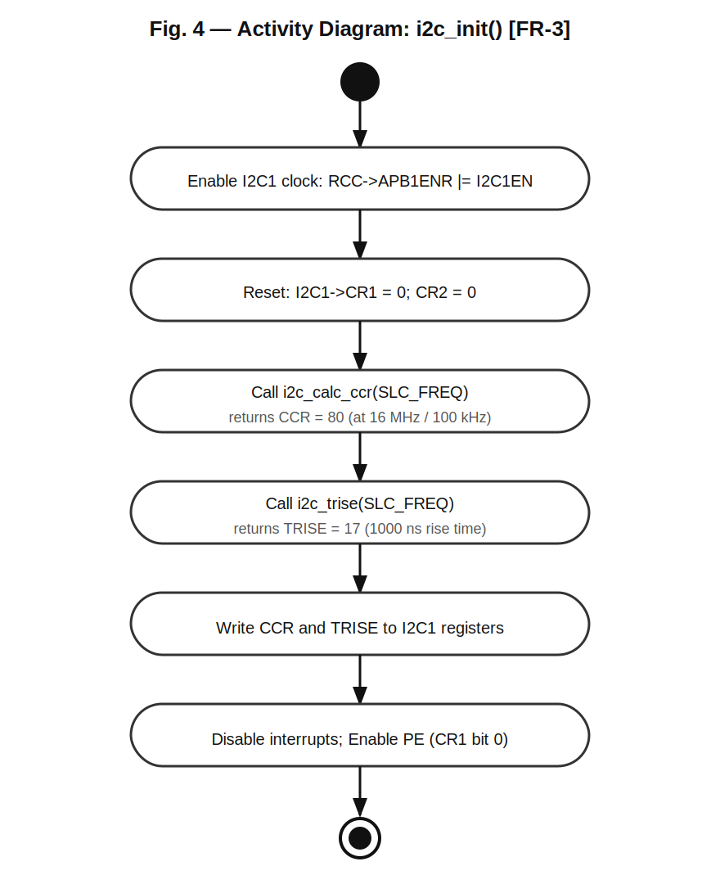
Fig. 4 — Activity Diagram: i2c_init() [FR-3]
Fig. 4 confirms the linear sequential flow of i2c_init(). There are no decision branches — the function always succeeds when called after GPIO configuration with a valid system clock. The six steps execute in fixed order without loops.

3.4. Write to Register — FR-4
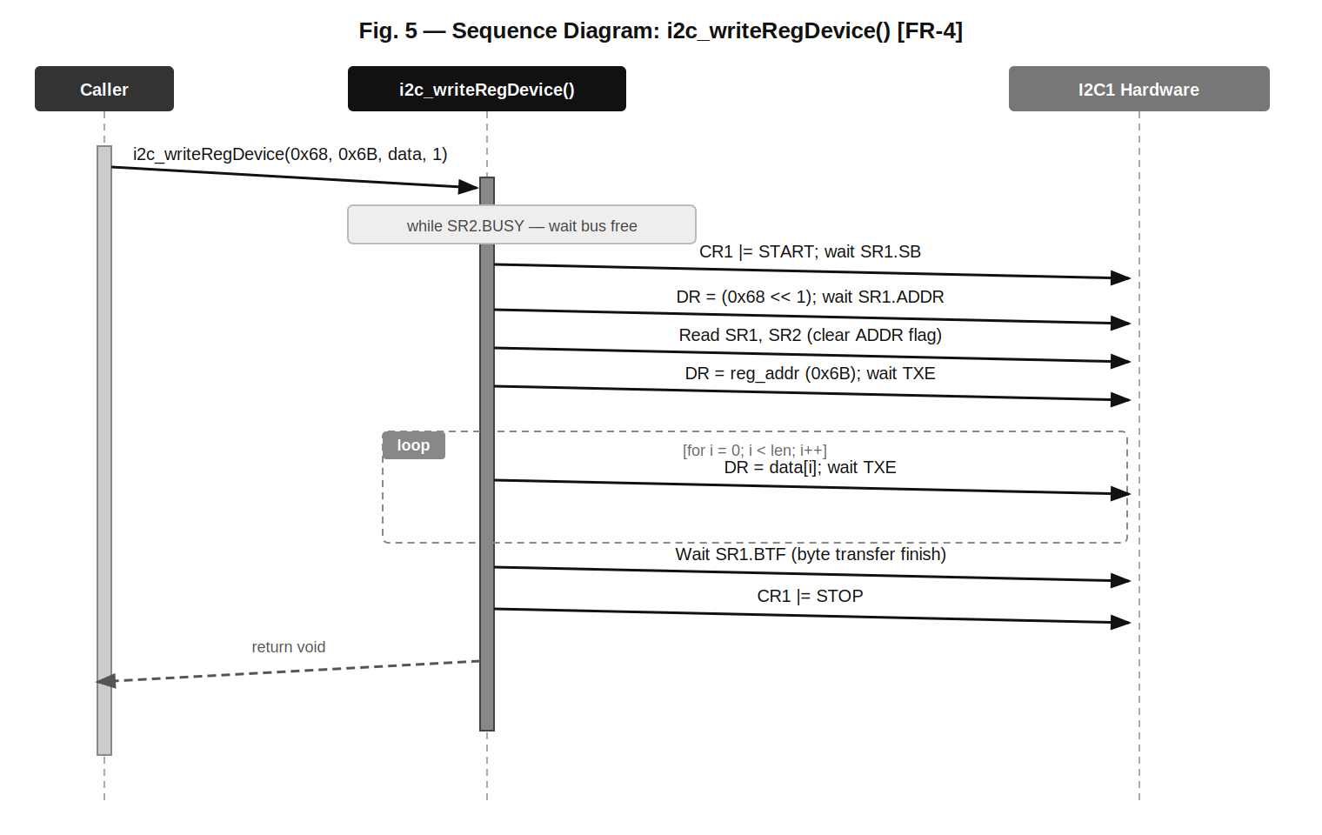
Fig. 5 — Sequence Diagram: i2c_writeRegDevice() [FR-4]
Fig. 5 shows the full I2C write-to-register transaction. The function first waits for the bus to be free (SR2.BUSY), generates a START condition, sends the 7-bit device address shifted left with the write bit (0), clears the ADDR flag by reading SR1 and SR2, sends the register address, then iterates through the data array sending each byte and polling TXE. After the last byte it waits for BTF (Byte Transfer Finished) before generating STOP.

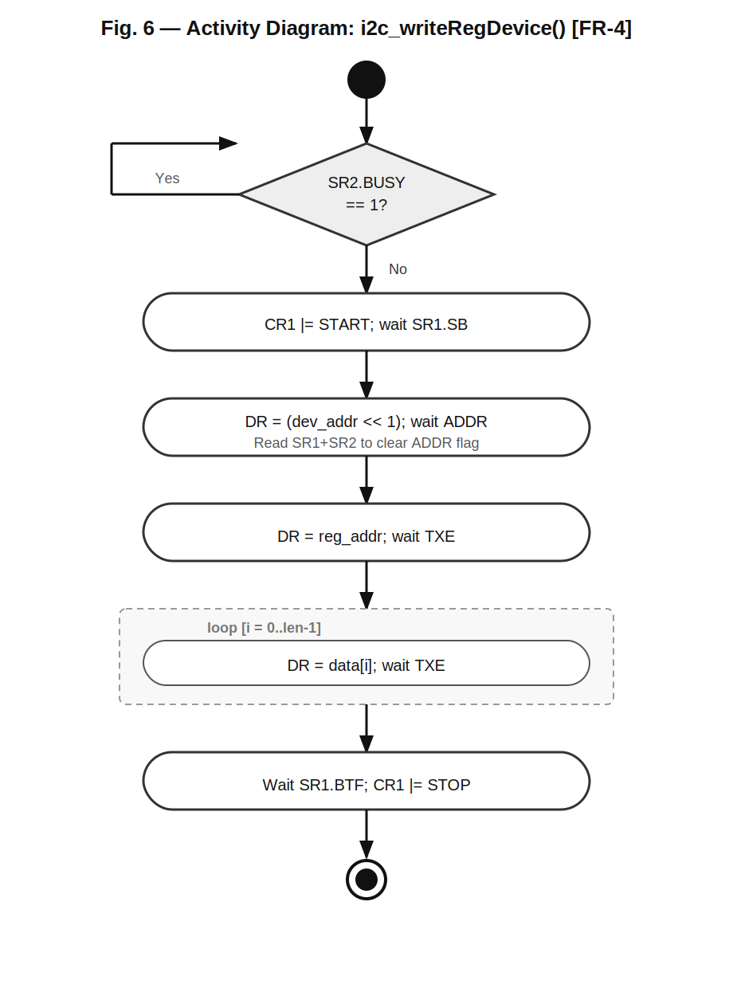
Fig. 6 — Activity Diagram: i2c_writeRegDevice() [FR-4]
Fig. 6 highlights the busy-wait diamond at entry and the transmission loop for data bytes. The BUSY poll loop prevents bus collisions. The TXE polling inside the data loop ensures each byte is fully loaded into the shift register before the next byte is written.

3.5. Read from Register — FR-6
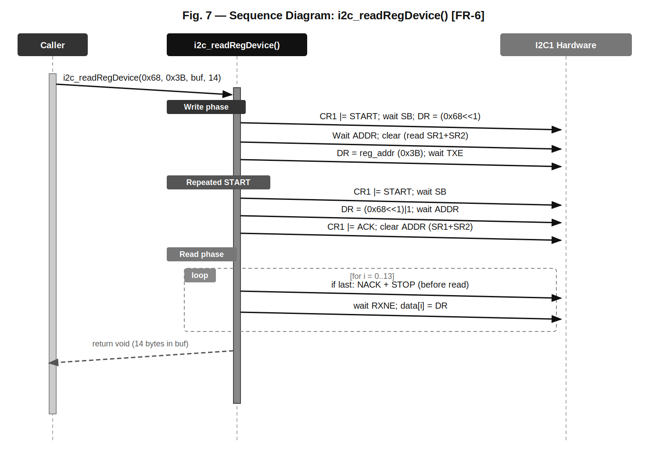
Fig. 7 — Sequence Diagram: i2c_readRegDevice() [FR-6]
Fig. 7 shows the two-phase read transaction. The write phase (START + device address + write bit + register address + TXE wait) establishes the target register on the device. A Repeated START then switches the bus direction; the device address is resent with the read bit (1), ACK is enabled, and bytes are received until the last byte where ACK is cleared and STOP is generated before the final DR read. This STOP-before-read-last-byte sequence is required by the STM32 I2C hardware state machine.

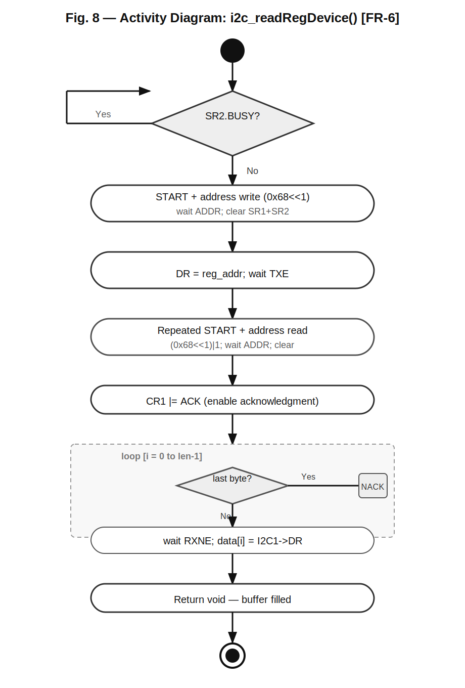
Fig. 8 — Activity Diagram: i2c_readRegDevice() [FR-6]
Fig. 8 shows the full activity flow including the BUSY wait at entry, the write phase, the repeated START branch, ACK enable, and the read loop with the decision diamond for the last-byte special case (NACK + STOP before reading).

3.6. State Diagram — I2C Driver System
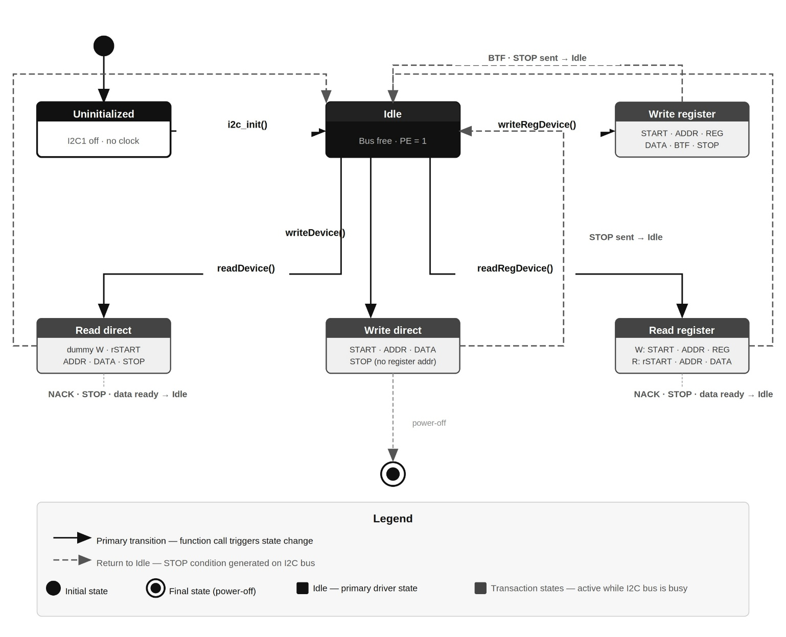

Fig. 9 shows the five runtime states of the I2C driver. From Uninitialized the driver moves to Idle after i2c_init(). From Idle it enters one of four transaction states: Write Register, Write Direct, Read Register, or Read Direct. All transaction states return to Idle after generating STOP and completing the transfer. The solid arrows indicate primary blocking transitions; dashed arrows indicate returns.

3.7. Driver Internals
CCR Calculation: CCR = SystemCoreClock / (2 * scl_freq_hz). For Standard Mode at 16 MHz: 16000000 / 200000 = 80. This formula targets 50% duty cycle SCL in Standard Mode (SM). Fast Mode (FM) would require a different formula (F/S bit in CCR + duty cycle selection), but this driver uses SM only.

TRISE Calculation: TRISE = (max_rise_ns * PCLK_MHz / 1000) + 1. For SM at 16 MHz: (1000 * 16 / 1000) + 1 = 17. For FM (400 kHz): (300 * 16 / 1000) + 1 = 5. This value sets the maximum allowed rise time in APB1 clock units.

ADDR Flag Clearing: The ADDR flag in SR1 is cleared by a sequential read of SR1 followed by SR2. The code uses void casts — (void)I2C1->SR1; (void)I2C1->SR2 — to prevent compiler warnings about discarded read values. This is a hardware-mandated sequence; failing to read SR2 after SR1 leaves ADDR set and blocks the bus.

Last Byte Protocol: For read operations, the STM32 I2C hardware requires that ACK be cleared and STOP be generated BEFORE reading the last byte from DR. The driver checks if (i == len-1) inside the read loop and, if true, clears CR1.ACK and sets CR1.STOP before the RXNE poll and DR read.

Bus Busy Guard: i2c_writeRegDevice() and i2c_readRegDevice() poll SR2.BUSY before proceeding. This prevents starting a new transaction while the bus is still active from a previous operation. i2c_writeDevice() and i2c_readDevice() do not include this guard.

4. Application Programming Interfaces

4.1. Data Types and Macros
SLC_FREQ: Macro defined in I2C.h. Default value = 100000 (100 kHz, Standard Mode). Can be overridden to 400000 for Fast Mode; TRISE formula adapts automatically.

No custom enumeration types are defined in this module. The driver uses only stdint.h types (uint8_t, uint32_t) and the CMSIS I2C_TypeDef and RCC_TypeDef register structures.

4.2. Register Map
Register | Offset/Address | Access | Used By / Purpose
RCC->APB1ENR | 0x40023840 | R/W | i2c_init() — bit 21 enables I2C1 clock
I2C1->CR1 | +0x00 | R/W | i2c_init() (reset, PE), all TX/RX functions (START, STOP, ACK)
I2C1->CR2 | +0x04 | R/W | i2c_init() — disable ITEVTEN, ITBUFEN, ITERREN
I2C1->CCR | +0x1C | R/W | i2c_init() — SCL clock control divisor (value: 80)
I2C1->TRISE | +0x20 | R/W | i2c_init() — max SCL rise time in APB1 clock units (value: 17)
I2C1->SR1 | +0x14 | R | All TX/RX — SB, ADDR, TXE, RXNE, BTF flag polling
I2C1->SR2 | +0x18 | R | All TX/RX — BUSY flag; read to clear ADDR when combined with SR1
I2C1->DR | +0x10 | R/W | All TX/RX — write byte to transmit; read received byte

4.3. Function Definitions

i2c_calc_ccr
Function Name | i2c_calc_ccr
Syntax | uint32_t i2c_calc_ccr(uint32_t scl_freq_hz)
Parameters (in) | scl_freq_hz | uint32_t — Desired SCL frequency in Hz (e.g., 100000 for 100 kHz Standard Mode).
Parameters (out) | N/A
Return value | uint32_t | CCR value to write to I2C1->CCR. For 16 MHz / 100 kHz returns 80.
Description | Computes the Clock Control Register value (FR-1). Formula: SystemCoreClock / (2 * scl_freq_hz). Assumes Standard Mode 50% duty cycle. Does not validate input.
Constraints | Division by zero if scl_freq_hz == 0. Fast Mode requires different CCR formula (F/S bit, duty cycle) — this function is for Standard Mode only. Called exclusively by i2c_init().
Available via | I2C.h

i2c_trise
Function Name | i2c_trise
Syntax | uint32_t i2c_trise(uint32_t scl_freq_hz)
Parameters (in) | scl_freq_hz | uint32_t — SCL frequency in Hz. Used to select rise time: 1000 ns (<=100 kHz), 300 ns (<=400 kHz), 120 ns (>400 kHz).
Parameters (out) | N/A
Return value | uint32_t | TRISE value to write to I2C1->TRISE. For 16 MHz / 100 kHz returns 17.
Description | Computes the maximum SCL/SDA rise time in APB1 clock cycles (FR-2). Formula: (max_rise_ns * PCLK_MHz / 1000) + 1. Selects max_rise_ns based on SCL mode. Called exclusively by i2c_init().
Constraints | Uses PCLK_MHz = SystemCoreClock / 1000000. Rounds down — actual rise time may be slightly above the TRISE register value.
Available via | I2C.h

i2c_init
Function Name | i2c_init
Syntax | void i2c_init(void)
Parameters (in) | N/A
Parameters (out) | N/A
Return value | void | Always succeeds. No error reporting.
Description | Initializes I2C1 peripheral (FR-3). Steps: (1) enable I2C1 clock via RCC->APB1ENR bit 21; (2) clear CR1 and CR2; (3) call i2c_calc_ccr(SLC_FREQ) and i2c_trise(SLC_FREQ); (4) write results to I2C1->CCR and I2C1->TRISE; (5) clear ITEVTEN, ITBUFEN, ITERREN in CR2; (6) set PE bit in CR1.
Constraints | Must be called after GPIO pins PB8 (SCL) and PB9 (SDA) have been configured to AF4 open-drain with pull-up. SLC_FREQ is a compile-time constant (100 000 Hz). SystemCoreClock must reflect the actual CPU frequency before calling this function.
Available via | I2C.h

i2c_writeRegDevice
Function Name | i2c_writeRegDevice
Syntax | void i2c_writeRegDevice(uint8_t device_address, uint8_t register_address, uint8_t *data, uint32_t len)
Parameters (in) | device_address | uint8_t — 7-bit I2C device address (e.g., 0x68 for MPU6050). Shifted left by 1 internally.
Parameters (in) | register_address | uint8_t — Target internal register address on the device (e.g., 0x6B for PWR_MGMT_1).
Parameters (in) | data | uint8_t* — Pointer to byte array to transmit. Must be valid for len bytes.
Parameters (in) | len | uint32_t — Number of bytes to write from data[].
Parameters (out) | N/A
Return value | void
Description | Writes len bytes to a specific register of an I2C device (FR-4). Sequence: wait BUSY; START; (dev<<1)+W; wait ADDR; clear ADDR; send reg_addr; wait TXE; loop: send data[i], wait TXE; wait BTF; STOP.
Constraints | Blocking — may hang indefinitely if bus is stuck or device does not ACK. No timeout. Not interrupt-safe. data pointer must not be NULL. Requires i2c_init() to have been called first.
Available via | I2C.h

i2c_writeDevice
Function Name | i2c_writeDevice
Syntax | void i2c_writeDevice(uint8_t device_address, uint8_t *data, uint32_t len)
Parameters (in) | device_address | uint8_t — 7-bit I2C device address. Shifted left by 1 internally.
Parameters (in) | data | uint8_t* — Pointer to byte array to transmit.
Parameters (in) | len | uint32_t — Number of bytes to write.
Parameters (out) | N/A
Return value | void
Description | Writes len bytes directly to an I2C device without register addressing (FR-5). Useful for devices that do not use internal register pointers. Sequence: START; (dev<<1)+W; wait ADDR; clear ADDR; loop: send data[i], wait TXE; STOP.
Constraints | No BUSY guard at entry — unlike i2c_writeRegDevice, this function does not wait for SR2.BUSY to clear before starting. Blocking. No BTF wait before STOP.
Available via | I2C.h

i2c_readRegDevice
Function Name | i2c_readRegDevice
Syntax | void i2c_readRegDevice(uint8_t device_address, uint8_t register_address, uint8_t *data, uint32_t len)
Parameters (in) | device_address | uint8_t — 7-bit I2C device address.
Parameters (in) | register_address | uint8_t — First register to read from; device auto-increments for burst reads.
Parameters (in) | len | uint32_t — Number of bytes to read.
Parameters (out) | data | uint8_t* — Buffer to store received bytes. Caller must allocate at least len bytes.
Return value | void
Description | Reads len bytes from a specific register of an I2C device (FR-6). Write phase: wait BUSY; START; (dev<<1)+W; wait ADDR; clear; send reg; wait TXE. Read phase: rSTART; (dev<<1)+R; wait ADDR; CR1|=ACK; clear; loop: if last -> NACK+STOP; wait RXNE; data[i]=DR.
Constraints | STOP must be generated BEFORE reading the last byte from DR — STM32 hardware requirement. Blocking. For len==1 the NACK and STOP are set immediately after enabling ACK. Used by MPU6050 to burst-read 14 bytes from ACCEL_XOUT_H.
Available via | I2C.h

i2c_readDevice
Function Name | i2c_readDevice
Syntax | void i2c_readDevice(uint8_t device_address, uint8_t *data, uint32_t len)
Parameters (in) | device_address | uint8_t — 7-bit I2C device address.
Parameters (in) | len | uint32_t — Number of bytes to read.
Parameters (out) | data | uint8_t* — Buffer to store received bytes.
Return value | void
Description | Reads len bytes directly from an I2C device without register addressing (FR-7). Includes a dummy write phase (START + address write) before the repeated START and read phase, for compatibility with devices that require it. Sequence mirrors i2c_readRegDevice() but omits the register address byte.
Constraints | Dummy write phase sends only the address byte with write bit — no data is transmitted. For devices that do not need a dummy write, this phase is harmless. Same last-byte NACK+STOP-before-read requirement applies.
Available via | I2C.h

5. Future Enhancements
- Support for Fast Mode (400 kHz): add F/S bit and duty cycle configuration in CCR; TRISE already adapts.
- Configurable peripheral selection: add an i2c_t enum (I2C_1, I2C_2, I2C_3) and an array of I2C_TypeDef* pointers, similar to the GPIO driver pattern.
- Timeout mechanism: add a counter-based timeout to all polling loops (SB, ADDR, TXE, RXNE, BTF, BUSY) to avoid infinite blocking on bus errors.
- Error detection and recovery: check ARLO, BERR, AF flags in SR1; implement bus reset (CR1 SWRST bit) on errors.
- Interrupt-driven and DMA-based transfers: add event/buffer/error interrupt support via CR2 ITEVTEN, ITBUFEN, ITERREN bits for non-blocking operation.
- Multi-master support: currently no arbitration-loss recovery; could add ARLO flag handling.
- 10-bit addressing: extend address transmission to support 10-bit I2C device addresses.

